Voice 773.994.8889
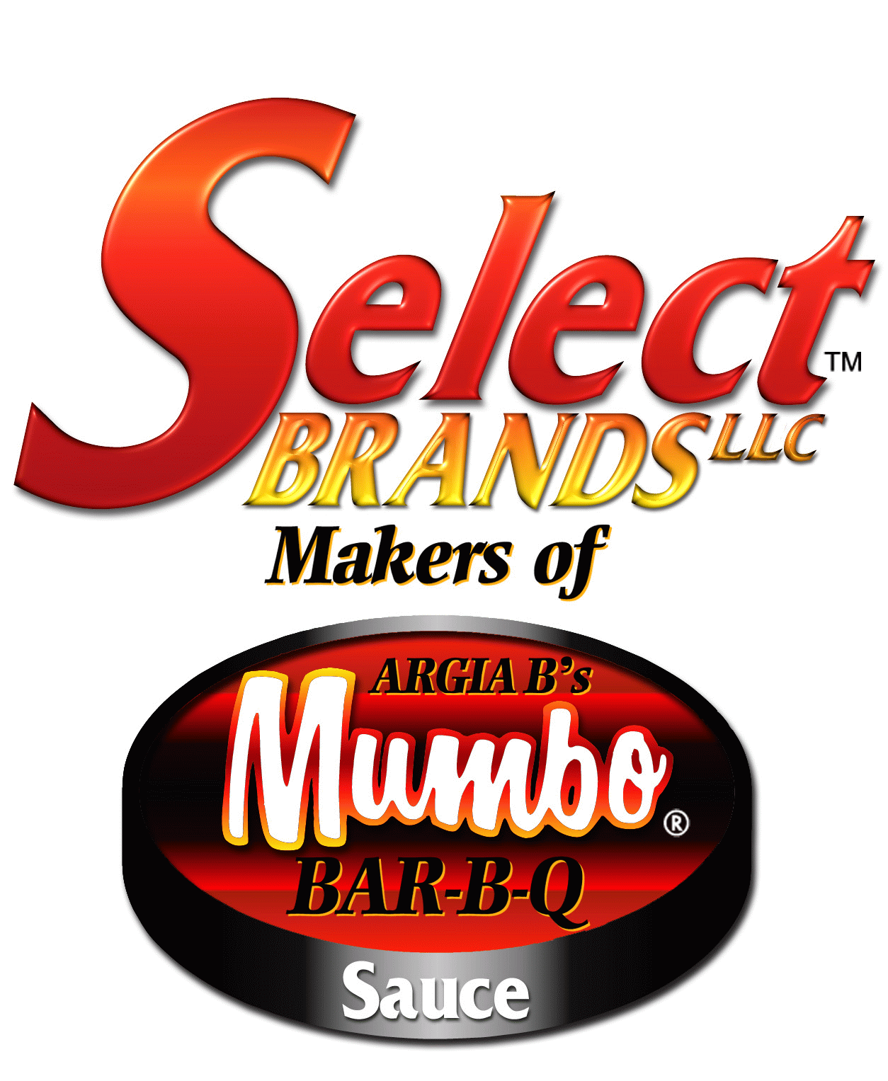
Fax 773.994.8974
SelectBrands@Hotmail.com
_________________________________________________________ P.O. Box 199361
CHICAGO, ILLINOIS 60619

OFFICIAL CONTEST RULES

Eligibility:

1. No purchase is necessary.
2. You must be at least eighteen (18) years old.
3. This Contest is subject to all federal, state and local laws. Void where prohibited by law. By entering, participants agree to these Official Rules.
4. Contest begins on June 29, 2006 and ends at midnight on July 19, 2006.
5. The contest is open to all Jewel-Osco customers residing in the states of Illinois and Wisconsin.
6. The odds of winning are based upon the total number of entries received during the contest period.
7. No mechanically reproduced entries are permitted. Illegible entries are void.
8. Employees of Jewel-Osco, Select Brands LLC, Magnolia Teas, New Orleans Bill Food Products, or their subsidiaries, distributors, franchisees, promoters, and agents of any of these, and the immediate families of the employees of any of these, are not eligible.

How To Enter:

9. By Mail: Complete the Contest entry form included in the Jewel Food Store Ad on June 29, 2006. Mail completed contest entry form to Select Brands LLC, P.O.Box 199361 Chicago, Illinois 60619. Or, on a plain 3 x 5 paper, hand print your complete name, street number (No P.O. Boxes), city, state, zip code, date of birth, age, email address, day and evening phone number. Mail your entry in a hand addressed stamped envelope to Select Brands LLC, P.O.Box 199361 Chicago, Illinois 60619. Limit one entry per stamped enveloped On-Line: Complete the on-line contest entry form at www.mumbobbqsauce.com. Click on Coupons & Contests. Select Contest Entry Form and complete all fields. Incomplete entry forms are void.

10. All entries must be received by July 19, 2006.

Random Drawing:

11. The winner will be selected in a random drawing on or about July 21, 2006 from the eligible mailed and on-line entries received. Decisions of judges are final. Winners will be notified by mail. One (1) grand prize will be awarded for this promotion.

PRIZES And Approximate Retail Value:
12. Description of prize: Winner will receive a Charcoal Grill from a brand name manufacturer with an approximate retail value of $300.00.
13. All federal, state and other taxes relating to any prize, and any travel, hotel accommodations or other expenses relating to any prize, are the sole responsibility of the winners. All federal, state and local laws apply.
14. Prizes are not transferable, substitutable, or exchangeable for cash except that the contest sponsors in its discretion may substitute a prize of equal or greater value. The prize carries no warranty of any type, whether express or implied, except as may be offered by manufacturer or otherwise required by law.

15. Acceptance of prize constitutes permission to the sponsors and their promotional participants to use winner’s name and or likeness for purposes of advertising and trade without further compensation, unless prohibited by law.

16. By accepting prize, winner agrees to hold Sponsors, their promotional participants and their respective directors, officers, employees and assigns, harmless against any and all claims and liability arising out of use of prize. Entrants assume all liability for any injury or damage caused or claimed to be cause by participation in this contest or the acceptance or use on any prize.

17. Return of any prize/prize notification as undeliverable will result in disqualification and an alternate winner will be selected.

MISCELLANEOUS
18. By entering, participants agree to these Official Rules. Select Brands LLC reserves the right to cancel, terminate or suspend this Contest or any part of this Contest should any non-authorized intervention, or other causes beyond its control corrupt or impair the security, administration, fairness and/or operation of this Contest as determined by Select Brands LLC in its sole discretion.
19. Select Brands LLC, its contest sponsors or promotional participants are not responsible for any typographical or other errors in the printing.
20. Not responsible for lost, late, damage, delayed, incomplete, illegible, mutilated, postage due mail, misdirected entries or entries not received by the entry deadline or for electronic, network or computer failures or malfunctions, or other technical errors of any kind.
21. For a list of winners, send a self-addressed stamped envelope by mail to Select Brands LLC P.O.B 199361 Chicago, Illinois 60619.

